Read out loud the text inside the triangle below.   
  
  
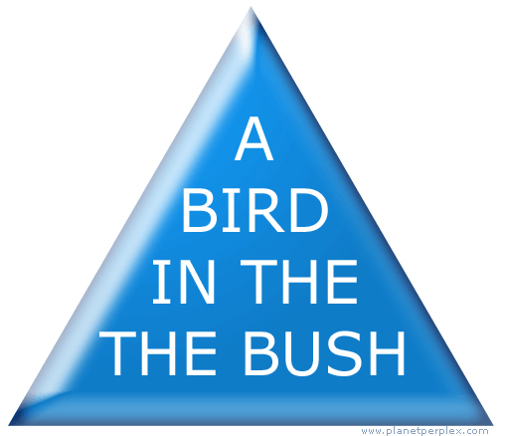  
  
  
More than likely you said, "A bird in the bush," and........   
  
if this IS what YOU said, then you failed to see   
  
that the word THE is repeated twice!   
  
Sorry, look again.   
  
  
  
Next, let's play with some words.   
  
What do you see?   
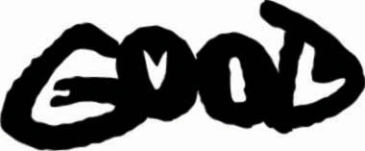  
  
  
In black you can read the word GOOD, in white the word EVIL (inside each black letter is a white letter). It's all very physiological too, because it visualize the concept that good can't exist without evil (or the absence of good is evil   
  
  
  
Now, what do you see?   
  
  
  
  
  
You may not see it at first, but the white spaces read the word optical, the blue landscape reads the word illusion. Look again! Can you see why this painting is called an optical illusion?   
  
  
What do you see here?   
  
  
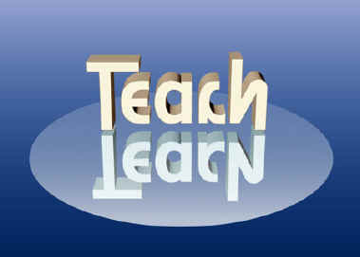  
  
This one is quite tricky!   
  
The word TEACH reflects as LEARN.   
  
  
  
Last one.   
  
What do you see?   
  
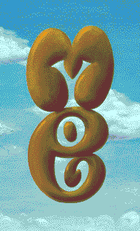  
  
  
You probably read the word ME in brown, but.......   
when you look through ME   
  
you will see YOU!   
  
Do you need to look again?   
 ***Test Your Brain***   
  
This is really cool. The second one is amazing so please read all the way though.   
  
  
  
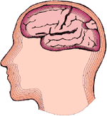 **ALZHEIMERS' EYE TEST**   
  
  
Count every "F " in the following text:   
  
FINISHED FILES ARE THE RE   
SULT OF YEARS OF SCIENTI   
FIC STUDY COMBINED WITH   
THE EXPERIENCE OF YEARS...   
  
(SEE BELOW)   
  
HOW MANY ?   
  
WRONG, THERE ARE 6 -- no joke.   
READ IT AGAIN !   
Really, go Back and Try to find the 6 F's before you scroll down.   
  
The reasoning behind is further down.   
  
The brain cannot process "OF".   
  
  
Incredible or what? Go back and look again!!   
  
Anyone who counts all 6 "F's" on the first go is a genius.   
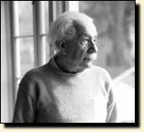  
  
Three is normal, four is quite rare.   
  
  
  
Send this to your friends.   
It will drive them crazy.!   
And keep them occupied   
For several minutes..  
  
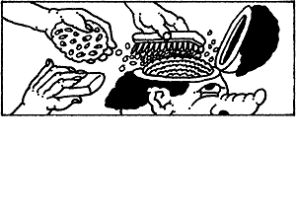 **More Brain Stuff . . . From** Cambridge University .  **Olny srmat poelpe can raed tihs.**  **I cdnuolt blveiee taht I cluod aulaclty uesdnatnrd waht I was rdanieg. The phaonmneal pweor of the hmuan mnid, aoccdrnig to a rscheearch at Cmabrigde Uinervtisy, it deosn't mttaer in waht oredr the ltteers in a wrod are, the olny iprmoatnt tihng is taht the frist and lsat ltteer be in the rghit pclae. The rset can be a taotl mses and you can sitll raed it wouthit a porbelm. Tihs is bcuseae the huamn mnid deos not raed ervey lteter by istlef, but the wrod as a wlohe. Amzanig huh? yaeh and I awlyas tghuhot slpeling was ipmorantt!  if you can raed tihs psas it on !!**   
Psas Ti ON !